**INTEL UNNATI GRAND CHALLENGE**

**SUMMER 2023**

**TECHNICAL REPORT**

ANALYSIS OF ACCIDENT PRONE AREAS FOR

INSTALLATION OF SURVEILLANCE CAMERA

**TEAM NAME :** CODE TRIAD

**TEAM MEMBERS :**

SHANMUGAPRIYA S V

SAMIKKSHA K

SEFIKA M

**ABSTRACT:**

Areas that are prone to accidents present significant hazards to the general public and necessitate continuous surveillance and action to reduce possible dangers. The purpose of this abstract is to provide a thorough review of the significance and advantages of surveillance systems in accident-prone regions, with a particular emphasis on how modern technology can improve security and safety.

**INTRODUCTION:**

Road safety is a major problem in India, considering accidents on roads cause substantial loss of life, injuries, and economic downturn. Early detection and avoidance of a collision is a superior alternative since it helps us minimize health casualties, property damage, fear among road drivers, and, most significantly, loss of life. The purpose of this research is to investigate the notion of collision detection and avoidance on roadways, their relevance in accident analysis, and mitigation measures.

**SCOPE AND OBJECTIVES:**

* Geographical areas identified as accident-prone.
* Deployment of advanced surveillance technology.
* Improve emergency response times.
* Continuously improve safety measures.

**RELATED WORK:**

* The primary goal of installing surveillance cameras is to identify

the speed of a vehicle using sensors and report it to the nearest police station.

* Weather sensors on surveillance systems is essential for early

warning systems that advise authorities and the public of dangerous weather conditions.

* During severe weather, surveillance cameras keep an eye on road

infrastructure, giving officials with visual data to assess damage, set priorities for repairs, and improve community readiness.

**ANALYSIS:**

**Tools:**

The following technologies were put to work by us for the analysis and presentation of the data:

* **SAS:** SAS (Statistical Analysis System) is a software suite used for advanced analytics, data management, and predictive modeling.
* **Power BI:** Another tool for data visualization is Microsoft Power BI, a tool that allows users to connect to many different sources of information, produce interactive reports, and share insights.
* **Python:** NumPy, Pandas, Matplotlib, and Seaborn are merely a few of the various libraries and packages available in this flexible programming language for data analysis. A popular tool for interactive analysis of data and visualization involves the Jupyter Notebook.

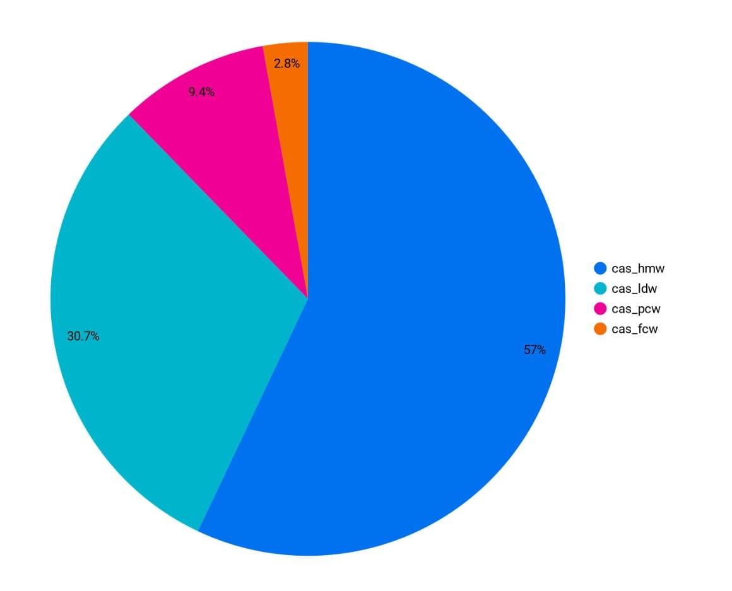

**Fig 1.1 : Pie chart showing percentage of Accident Alert**

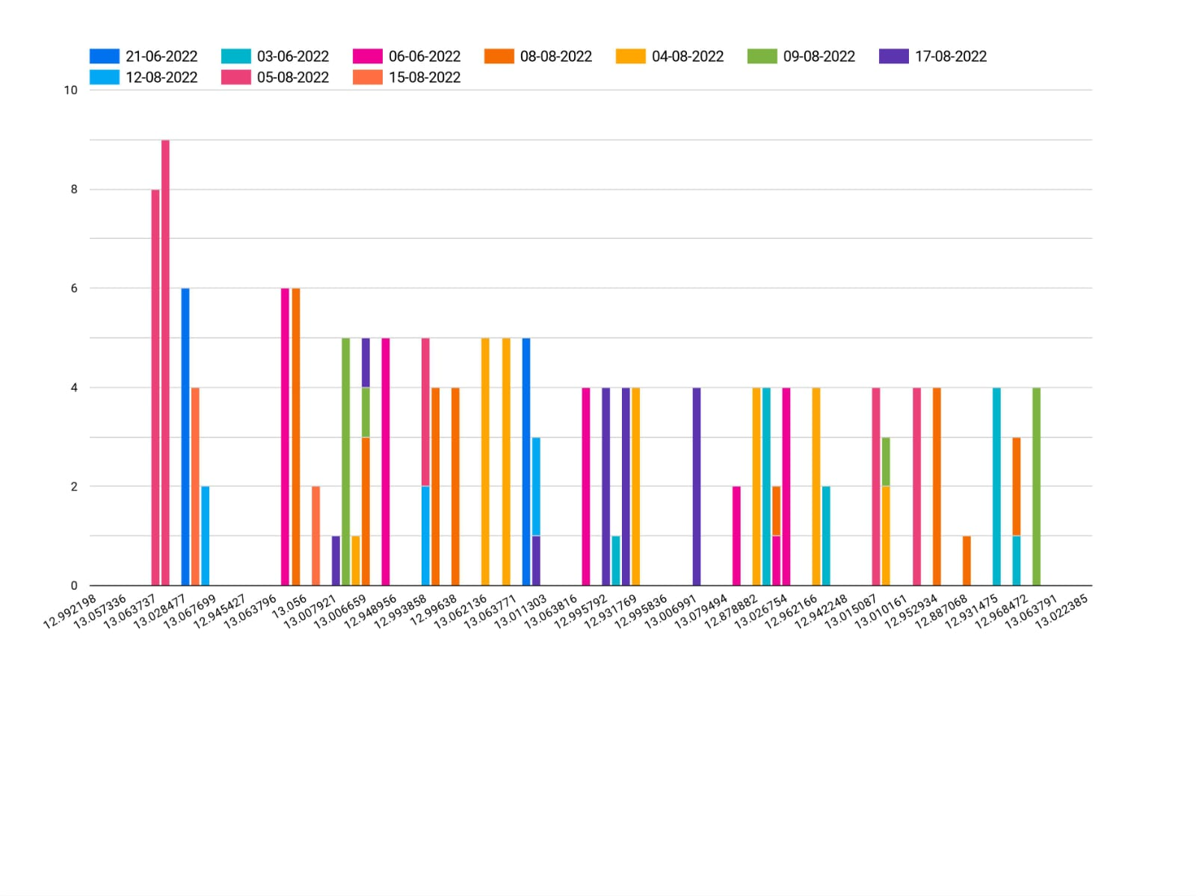

**Fig 1.2: Stacked column chart showing Latitude , Longitude and Date**

**REFERNCES:**

1."A Survey of Big Data Architectures and Machine Learning Algorithms

in Traffic Sensor Data Analysis" by He, S., Wu, D., & Zhang, G. (2019) : This study explores the use of surveillance data for traffic management and accident prevention through machine learning algorithms.

2. "Real-time monitoring of a surveillance area to assist in the prevention of accidents" by Zheng, Y., & How, J. P. (2017): This paper discusses real-time surveillance and monitoring for accident prevention and rapid emergency response.

3. "Remote Sensing and GIS for Disaster Management" by Kumar, V., & Satyam, N. (2017): This book discusses the use of surveillance and remote sensing technologies for disaster management in accident-prone areas.

**CONCLUSION:**

In order to increase safety, it is crucial to deploy surveillance systems in locations that have a lot of traffic accidents. These technologies improve traffic management, speed up emergency response times, assist reduce accidents, and curb criminal activity. To establish a balance between safety and individual rights, privacy issues and ethical issues must be carefully considered.